Questions Round 1

1. *What is the base pressure of the system?* That is, how long before a monolayer covers the surface?
2. *What oxygen and carbon contamination is estimated from core level photoemission spectra?*
3. *What was the cleaning procedure? How many cycles of sputtering (what ion and energy?) and annealing (what temperature)?*
4. *Could you please send a LEED which is representative of the surface region from which the ARPES spectra were acquired?*
5. *What is the binding energy resolution of the detector?*
6. *What is the angular resolution of the detector? In other words, what is the largest bound on the resolution of the in-plane wavevector Δk||?*
7. *Beam polarization?*

Linearly polarized photons in the horizontal plane of the synchrotron, even with respect to scattering plan.

1. *What would happen if the system were rotated to have the beam polarized along the vertical plane? Would the selection rules change?* For example, you note in the text that only orbitals with even symmetry with respect to the scattering plane can be excited by horizontally polarized photons. I have preliminary Fermi surface simulations which show the existence of some bands which are missing in the ARPES data. Could measurements in the vertical plane change selection rules and reveal these bands? I am in the process of analyzing the initial state symmetries.
2. *Is the data presented in Figure 4 measured by changing polar angle or by changing photon energy?* For example, in the text you write that ARPES data is recorded at constant photon energy (146 eV), as a function of polar angle along [100] and [01-1] azimuths. (surface normal is [011]).
3. *Can we also include measurements as a function of polar angle along the Λ azimuth, i.e. [11-1]?*
4. *The right panel in Figure 3 shows an arc corresponding to a 146-eV free-electron final state. What was the inner potential and effective mass used the curve?*
5. *What type of symmetry averaging is performed in Figure 5(a)?*
6. *The dark background at high polar angles in the Fermi surface map is very similar to the defocusing effect observed in XRD pole figures. What common background subtraction methods used by the ARPES community?*
7. *What was the range in the polar angle used to map the Fermi surface shown in Figure 6? Also, was refraction of photoexctied electrons taken into account when converting the polar angle to in-plane wavevector? Does this map, as plotted correspond to a* ***planar*** *or* ***non-planar*** *slice through the Brillouin zone?*

Could you please share:

1. The raw spectra obtained along azimuths [01-1] and [100] by changing the polar angle as well as the corresponding constant-initial state maps obtained by varying the photon energy? It would be very helpful to spectra which includes the entire bandwidth of pd electrons and is not limited to the range of the plots shown in figure 5b.
2. The raw spectra corresponding to figure 6.
3. The raw spectra corresponding to figure 7.

Questions Round 1

1. *What is the range of incident photon energies which are possible?* Avoid energies corresponding to core levels for which Auger excitations occur.

Proposal

1. Normal state emission as a function of temperature and incident photon energy (enough to span three brilllouin zones)

Notes

1. Why use the 011 surface? The 011 surface exhibits the lowest symmetry (two-fold) among the three primary cubic facets (111 is three-fold, and 001, four-fold symmetric) and contains K, L, and X correspond to [011], [111], and [001] high-symmetry zone-boundary points.

method (pole figure) provides a non-planar cut through the Fermi surface using a fixed photon energy. Stampfl’s method (constant initial state) gets a planar slice but requires variable photon nergy.

Hunfer

Photoelectron spectroscopy (PES) measured final states with one electron missing. Band structure calculations within the single particle approximation yield initial states since band energies are not altered by the ejection of electrons.

PES experiment conserves energy (ℏω = Ef – Ei) and wavevector (G = kf – ki). With the detector placed at surface normal, the in-plane wave vector component is restricted to zero. Thus, the final states must have k|| = 0. Dispersion of free electron final states are given by:

$$E=\frac{ℏ^{2}\left|k+G\right|}{2m}$$

If the surface is [001], final states must be based on G = [0,0,α] for integers α. Other reciprocal lattice vectors G produce final states corresponding to photoejected electrons traveling off-normal and are not observed by the detector. [Hunfer, p 475]

The final free electron state has wave vector k = ki + G and cannot be translated back into the first Brillouin zone. [Hunfer, p 350, 352]

Screening of photo-hole is neither instantaneous nor complete. [Hunfer, ch 3]

Typical XPS setups use Al Kα (1487 eV) or Mg Kα (1254 eV) source. The in-plane wave vector of the final state is approximatley $k_{||}=5 \sin{θ} nm^{-1}$ with a spread ${δk}_{||}=5 δθ\cos{θ} nm^{-1}$. For an electron analyzer angular acceptance of δθ = 2o, δk|| = 6 nm-1.

The Brillouin zone of VN is for example 2π/a ~ 10 nm-1. As a result, the in-plane component of the final state wavevector is averaged over most of the Brillouin zone. [Hunfer, p 348]

At energies exceeding ~ 1 keV, photons transfer non-negligible momenta to photoexcited electrons -- the wave number of photon with energy E = 1.5 keV is p = E/(ℏc) ~7 nm-1. [Hunfer, p 348]

XPS spectra are thus modulated by angular projection factor and angular-momentum-dependent photoelectron cross-sections. [Hunfer, p 349]

In the one-step model an electron is excited from an initial Bloch wave into a damped final state near the surface (damping attenuates electron amplitude simulating scattering and short mean free path). In the three step model: 1) photoexcitation, 2) diffusion to surface, 3) penetration into vacuum. One-step model is most rigorous than three-step model.

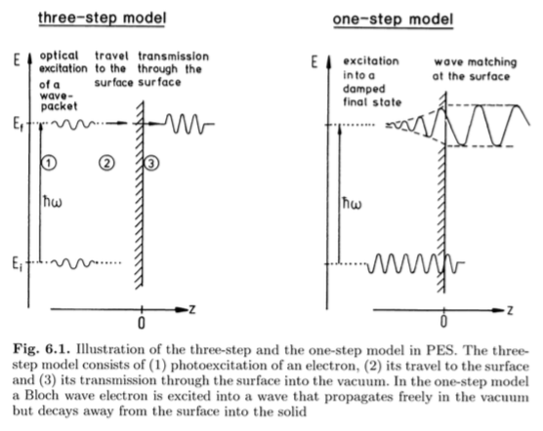

Three steps:

Step 1:

Step 2: The fraction of photo electrons generated within a mean-free-path of the surface is

$$\sim \frac{αλ}{a+αλ}$$

in which α is the optical absorption coefficient and λ the electron mean free path. [Hunfer, p 353]

Step 3: Essentially the same as thermionic emission over a barrier. Electrons with kinetic energy component normal to the surface which exceeds the barrier height EB are able to escape. Thus [Hunfer, p 354]:

$$\frac{ℏ}{2m}K_{⊥}^{2}>E_{B}$$

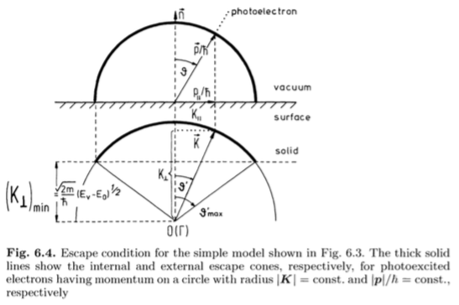

have such large angular acceptance that the final state wave vector is averaged over the Brillouin zone.

UPS: He I or He II

Kinetic energy of electron changes as it crosses interfaces because the potential from which it is measured varies. This causes a refraction effect, similar to snell’s law. Deviations from snell’s law increases as 1 + (Ef+Φ)/Ek for fermi level Ef, work function φ, and measured electron kinetic energy Ek. At most, the deviation amounts to a few percent (minimal effect). [Hunfer, p 355; *Cazaux 2013*]

$$\sqrt{E_{s}}\sin{α}=\sqrt{E_{k}}\sin{β}$$

